**SQL ASSIGNMENT – 1**

1)  Write an SQL query to fetch “FIRST_NAME” from Worker table using the alias name as <WORKER_NAME>.

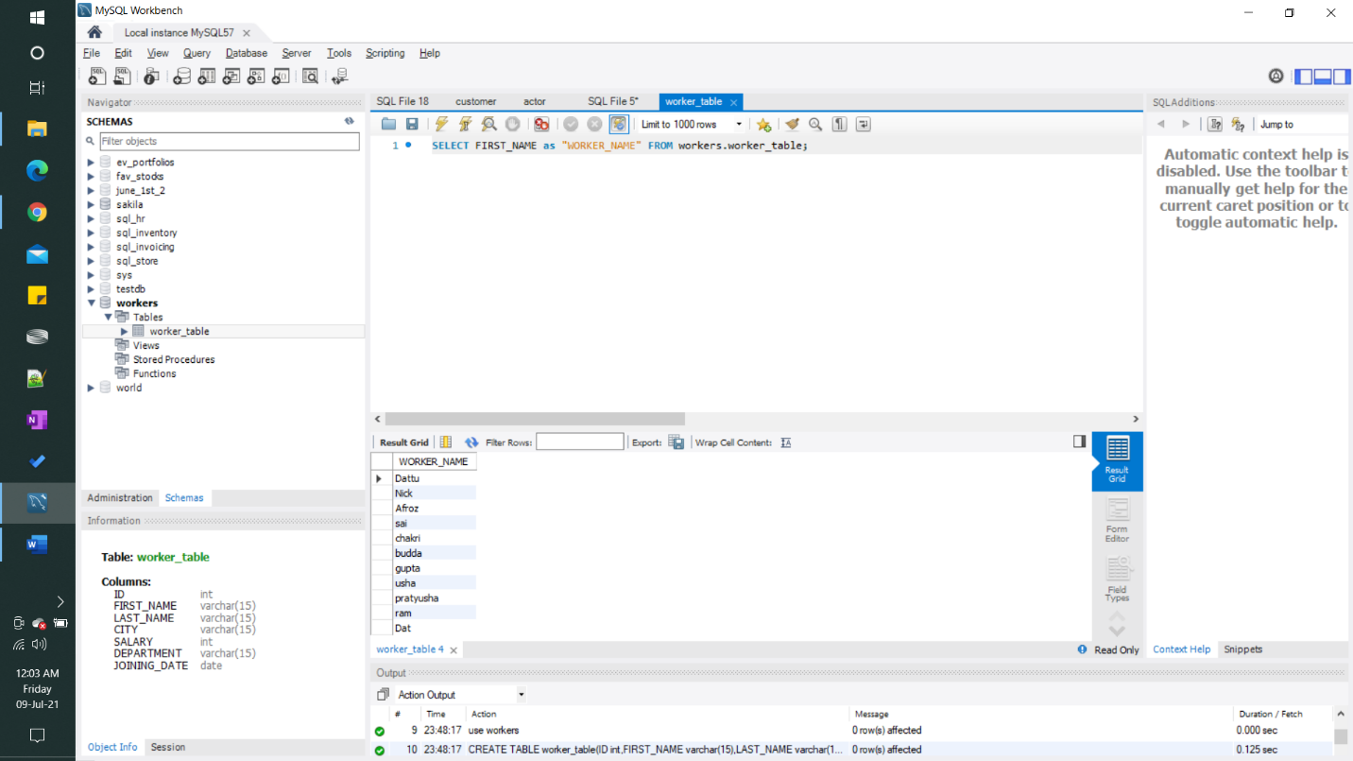

#### 2) Write an SQL query to fetch unique values of DEPARTMENT from Worker table.

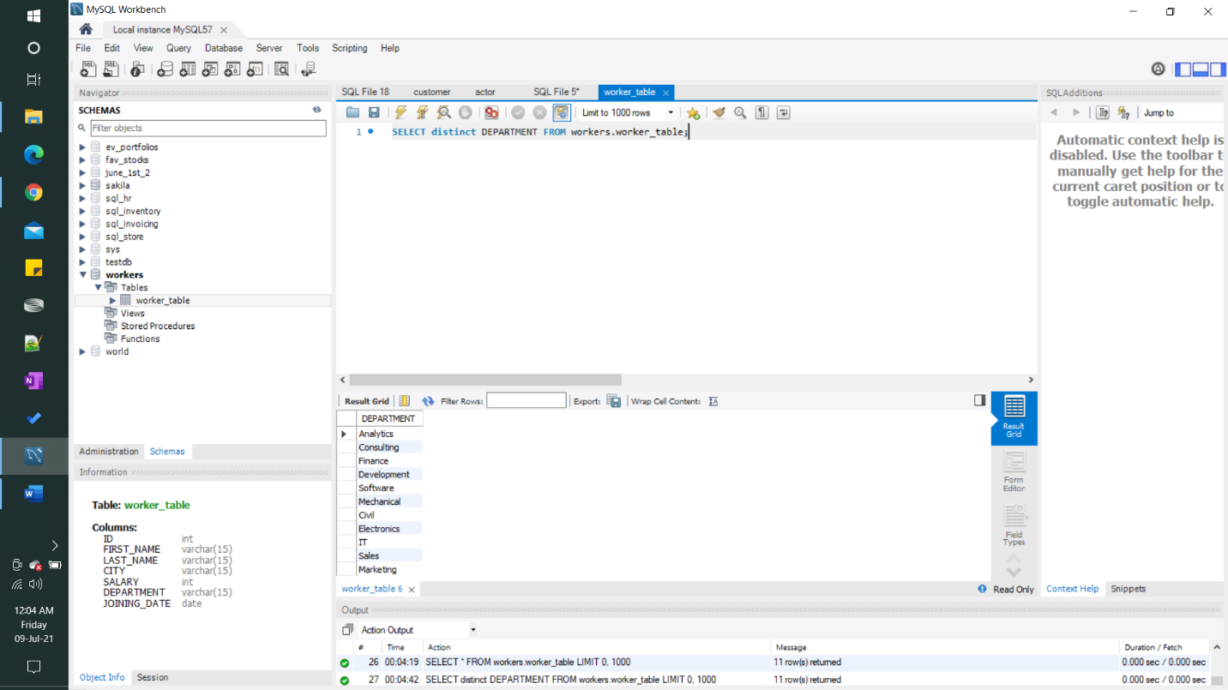

#### 3) Write an SQL query to show the last 5 record from a table.

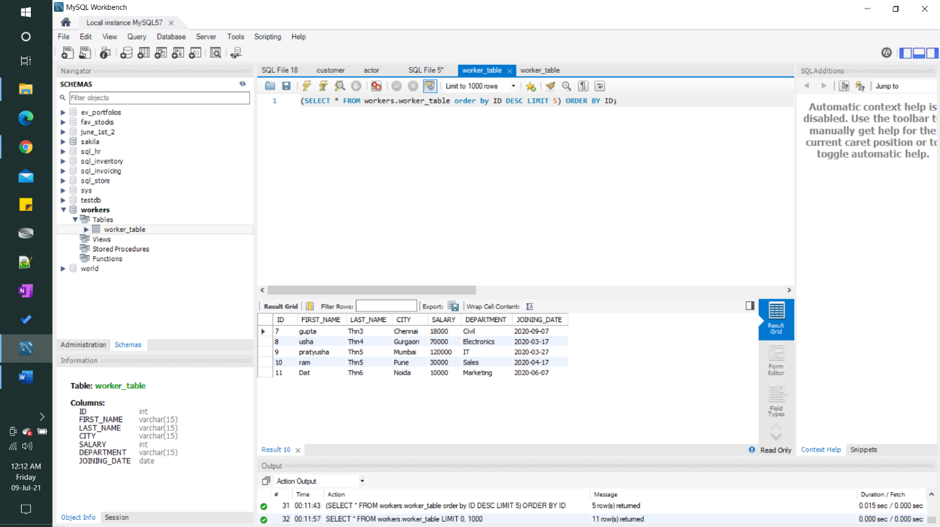

**DATA IN THE WORKERS DATABASE (SCHEMA):**

